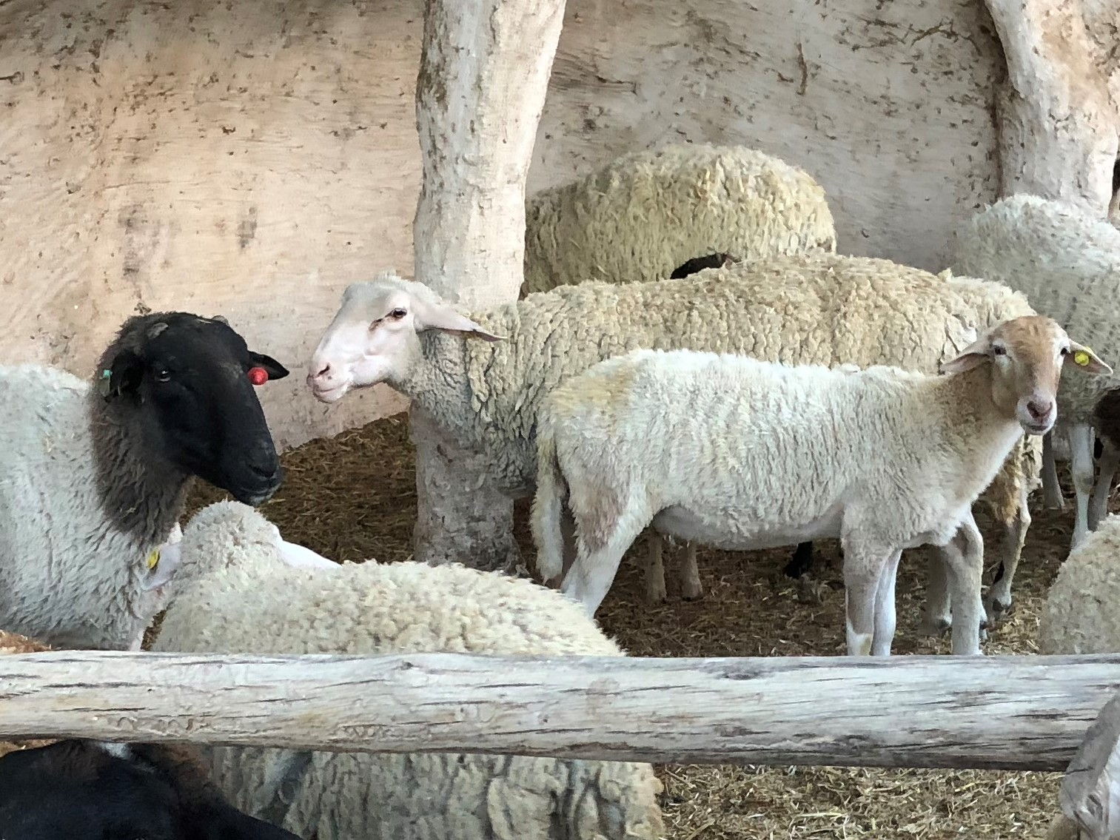
Sunday, April 25th – Easter 4

Welcome Everyone! We hope you find our Livestream gathering a time of spiritual renewal and encouragement.

This Week’s Ministry Team
Officiant/Preacher – The Rev. Stephen Laskey
Music & Psalmist – Matthew Ma
Gospeller – Neil Seedhouse
Prayers of the Community – Neil Seedhouse
Reader – Wendy Russell

The Gathering of the Community

Prelude – He is Lord, He is Lord
He is risen from the dead, And He is Lord
Ev’ry knee shall bow, ev’ry tongue confess
That Jesus Christ is Lord

The Greeting
Alleluia! Christ is Risen.
The Lord is risen indeed. Alleluia!

May his grace and peace be with you.
May he fill our hearts with joy.

Words of Welcome
Collect for Purity
Almighty God,
to you all hearts are open, all desires known,
and from you no secrets are hidden.
Cleanse the thoughts of our hearts by the inspiration of your Holy Spirit, that we may perfectly love you,
and worthily magnify your holy name;
through Christ our Lord. Amen.

Hymn of Praise – Here in this Place
Here in this place, new light is streaming
now is the darkness vanished away,
see, in this space, our fears and our dreamings,
brought here to you in the light of this day.
Gather us in the lost and forsaken
gather us in the blind and the lame;
call to us now, and we shall awaken
we shall arise at the sound of our name.

We are the young – our lives are a mystery
we are the old – who yearns for your face.
we have been sung throughout all of history
called to be light to the whole human race.
Gather us in the rich and the haughty
gather us in the proud and the strong
give us a heart so meek and so lowly
give us the courage to enter the song.

Here we will take the wine and the water
here we will take the bread of new birth
here you shall call your sons and your daughters
call us anew to be salt of the earth.
Give us to drink the wine of compassion
give us to eat the bread that is you
nourish us well and teach us to fashion
lives that are holy and hearts that are true.

Not in the dark of buildings confining,
Not in some new heaven light years away,
But here in this place the new light is shining,
Now is the kingdom, now is the day
Gather us in and hold us forever,
Gather us in and make us your own;
Gather us in all peoples together,
Fire of love in our flesh and our bone

Contributors: Marty Haugen
© 1982, GIA Publications, Inc.
Reprinted with permission under ONE LICENSE #A-734895

The Collect of the Day
O God of peace,
who brought again from the dead our Lord Jesus Christ,
that great shepherd of the sheep,
by the blood of the eternal covenant,
make us perfect in every good work to do your will,
and work in us that which is well-pleasing in your sight;
through Jesus Christ our Lord. Amen.

The Proclamation of the Word

First Reading – Acts 4:5–12
The rulers, elders, and scribes assembled in Jerusalem, with Annas the high priest, Caiaphas, John, and Alexander, and all who were of the high-priestly family. When they had made the prisoners stand in their midst, they inquired, “By what power or by what name did you do this?” Then Peter, filled with the Holy Spirit, said to them, “Rulers of the people and elders, if we are questioned today because of a good deed done to someone who was sick and are asked how this man has been healed, let it be known to all of you, and to all the people of
Israel, that this man is standing before you in good health by the name of Jesus Christ of Nazareth, whom you crucified, whom God raised from the dead. This Jesus is ‘the stone
that was rejected by you, the builders; it has become the cornerstone.’ There is salvation in no one else, for there is no other name under heaven given among mortals by which we must be saved.”
Listen to what the Spirit is saying to the Church.
Thanks be to God

Psalm 23
1 The Lord is my shepherd; *
I shall not be in want.

2 You make me lie down in green pastures *
and lead me beside still waters.

3 You revive my soul *
and guide me along right pathways for your name’s sake.
4 Though I walk through the valley of the shadow of death, *
I shall fear no evil;

for you are with me; *
your rod and your staff, they comfort me.

5 You spread a table before me *
in the presence of those who trouble me;

you have anointed my head with oil, *
and my cup is running over.

6 Surely goodness and mercy shall follow me all the days of my life, *
and I will dwell in the house of the Lord for ever.

Glory to God, Source of all being, eternal Word and Holy Spirit:
as it was in the beginning, is now and will be for ever. Amen

Second Reading – 1 John 3:16–24
We know love by this, that he laid down his life for us—and we ought to lay down our lives for one another. How does God’s love abide in anyone who has the world’s goods and sees a brother or sister in need and yet refuses help? Little children, let us love, not in word or speech, but in truth and action. And by this we will know that we are from the truth and will reassure our hearts before him whenever our hearts condemn us; for God is greater than our hearts, and he knows everything. Beloved, if our hearts do not condemn us, we have
boldness before God; and we receive from him whatever we ask, because we obey his commandments and do what pleases him. And this is his commandment, that we should believe in the name of his Son Jesus Christ and love one another, just as he has commanded us. All who obey his commandments abide in him, and he abides in them. And by this we know that he abides in us, by the Spirit that he has given us.
Listen to what the Spirit is saying to the Church
Thanks be to God

Gospel Acclamation
Alleluia! Alleluia! Alleluia
Call us Good Shepherd, we listen for you,
Wanting to see you in all that we do.
We would the gate of salvation pass through:
Alleluia! Alleluia! Alleluia!

The Gospel – John 10:11-18
The Lord be with you.
And also with you.

The Holy Gospel of our Lord Jesus Christ according to John
Glory to you, Lord Jesus Christ.

Jesus said, “I am the good shepherd. The good shepherd lays down his life for the sheep. The hired hand, who is not the shepherd and does not own the sheep, sees the wolf coming and leaves the sheep and runs away—and the wolf snatches them and scatters them. The hired hand runs away because a hired hand does not care for the sheep. I am the good shepherd.
I know my own and my own know me, just as the Father knows me and I know the Father. And I lay down my life for the sheep. I have other sheep that do not belong to this fold. I
must bring them also, and they will listen to my voice. So there will be one flock, one shepherd. For this reason the Father loves me, because I lay down my life in order to take it up again. No one takes it from me, but I lay it down of my own accord. I have power to lay it down, and I have power to take it up again. I have received this command from my Father.”

The Gospel of Christ
Praise to you, Lord Jesus Christ

Alleluia! Alleluia! Alleluia!

Homily – Father Steve

The Apostles Creed
Let us confess the faith of our baptism, as we say,
I believe in God, the Father almighty,
creator of heaven and earth.
I believe in Jesus Christ, his only Son, our Lord.
He was conceived by the power of the Holy Spirit
and born of the Virgin Mary.
He suffered under Pontius Pilate,
was crucified, died, and was buried.
He descended to the dead.
On the third day he rose again.
He ascended into heaven,
and is seated at the right hand of the Father.
He will come again to judge the living and the dead.
I believe in the Holy Spirit, the holy catholic Church,
the communion of saints, the forgiveness of sins,
the resurrection of the body, and the life everlasting. Amen

Prayers of the Community
The flowers on the altar this morning are given for the glory of God by Maureen Thompson In loving memory of sister in-law Cathie and nephew Craig Pierce and by Pat Nociar In memory of a loving husband, Steve Nociar

Anglican Church of Canada – we pray for our primate, Archbishop Linda Nichols. We also pray for The Rt. Rev. Todd Townshend, Bishop, and the clergy and people of the
Diocese of Huron

Anglican Communion – we pray for the Anglican/Episcopal Church of Japan, The Nippon Sei Ko Kai.

In our Diocesan Cycle we pray for our Bishop, the Rt. Rev. John Stephens. We also pray for St. Mark, Ocean Park, St. Philip, Vancouver and the Archdeaconry of Capilano, The Ven Stephen Muir, Archdeacon.
We also pray for our companion diocese of Northern Philippines. We pray for its Prime Bishop, the Rt. Rev. Brent Alawas as the diocese awaits the election of a new bishop. We prayer for our own twinned parish of Holy Apostles, Abatan, and their priest, Father Joey Napat-a.
We pray for the people and clergy and for the ministries flowing from these places into the communities.

In our Parish Cycle we pray for Joan Fletcher, Amelia Foster, Kelly & Les Foulds, and Roy & Josie Francis.

An Act of Reconciliation
Dear Friends, God is steadfast in love and infinite in mercy. God welcomes sinners and invites them to this table. Let us confess our sins confident in God’s forgiveness.

Most merciful God,
Father of our Lord Jesus Christ,
we confess that we have sinned in thought, word and deed.
We have not loved you with our whole heart.
We have not loved our neighbours as ourselves.
In your mercy forgive what we have been,
help us to amend what we are, and direct what we shall be;
that we may do justly, love mercy,
and walk humbly with you, our God. Amen.

Almighty God have mercy upon you, pardon and deliver you from all your sins, confirm and strengthen you in all goodness,
and keep you in eternal life; through Jesus Christ our Lord. Amen.

The Peace
The peace of the Lord be always with you.
And also with you.
The Celebration of the Eucharist

Offertory Hymn – The Lord’s My Shepherd
The Lord’s My Shepherd
The Lord’s my shepherd, I’ll not want;
he makes me down to lie
in pastures green; he leadeth me
the quiet waters by.

My soul he doth restore again,
and me to walk doth make
within the paths of righteousness,
e'en for his own name’s sake.

Yea, though I walk through death’s dark vale,
yet will I fear none ill;
for thou art with me,
and thy rod and staff me comfort still.

My table thou has furnished
in presence of my foes;
my head thou dost with oil anoint,
and my cup overflows.

Goodness and mercy all my life
shall surely follow me;
and in God’s house for evermore
my dwelling-place shall be.

Prayer over the Gifts
God of loving care,
you spread before us the table of life,
and give us the cup of salvation to drink.
Keep us always in the fold of your Son Jesus Christ,
our Saviour and our shepherd. Amen

The Great Thanksgiving
The Lord be with you.
And also with you.

Lift up your hearts.
We lift them to the Lord.

Let us give thanks to the Lord our God.
It is right to give our thanks and praise.

It is indeed right that we should praise you, gracious God,
for you created all things. You formed us in your own image:
male and female you created us. When we turned away from you in sin, you did not cease to care for us,
but opened a path of salvation for all people.

You made a covenant with Israel, and through your servants Abraham and Sarah gave the promise of a blessing to all nations. Through Moses you led your people from bondage into freedom; through the prophets you renewed your promise of salvation. Therefore, with them, and with all your saints
who have served you in every age, we give thanks and raise our voices to proclaim the glory of your name.

Holy, holy, holy Lord,
God of power and might,
heaven and earth are full of your glory.
Hosanna in the highest.
Blessed is he who comes in the name of the Lord.
Hosanna in the highest.

Holy God, source of life and goodness,
all creation rightly gives you praise.
In the fullness of time, you sent your Son Jesus Christ, to share our human nature, to live and die as one of us, to reconcile us to you, the God and Father of all.
He healed the sick and ate and drank with outcasts and sinners;
he opened the eyes of the blind
and proclaimed the good news of your kingdom
to the poor and to those in need.
In all things he fulfilled your gracious will.
On the night he freely gave himself to death,
our Lord Jesus Christ took bread,
and when he had given thanks to you,he br oke it, and gave it to his disciples, and said, “ Take, eat: this is my body which is given for you. Do this for the remembrance of me.”
After supper he took the cup of wine; and when he had given thanks, he gave it to them, and said, “Drink this, all of you:
this is my blood of the new covenant, which is shed for you and for many for the forgiveness of sins.
Whenever you drink it, do this for the remembrance of me.”
Gracious God, his perfect sacrifice
destroys the power of sin and death;
by raising him to life you give us life for evermore.
Therefore we proclaim the mystery of faith.
Christ has died. Christ is risen. Christ will come again.

Recalling his death, proclaiming his resurrection,
and looking for his coming again in glory,
we offer you, Father, this bread and this cup.
Send your Holy Spirit upon us and upon these gifts,
that all who eat and drink at this table
may be one body and one holy people,
a living sacrifice in Jesus Christ, our Lord.
Through Christ, with Christ, and in Christ,
in the unity of the Holy Spirit,
all glory is yours, almighty Father, now and for ever. Amen

Silence is kept

The Lord’s Prayer
Rejoicing in God’s new creation,
let us pray as our Redeemer has taught us.
Our Father in heaven, hallowed be your name,
your kingdom come, your will be done,
on earth as in heaven.
Give us today our daily bread.
Forgive us our sins as we forgive those who sin against us.
Save us from the time of trial and deliver us from evil.
For the kingdom, the power, and the glory are yours,
now and for ever. Amen.
The Breaking of the Bread
Lord, we died with you on the cross.
Now we are raised to new life.

We were buried in your tomb.
Now we share in your resurrection.

Live in us, that we may live in you.

Agnus Dei
O Lamb of God, You take away the sins of the nations,
Have mercy on us
O Lamb of God You take away the guilt of creation
Have mercy on us.
O Lamb of God I am not worthy,
Yet say one word that will heal my wounded spirit.
O Lamb of God You take away the sins of Your people,
O Grant us Your peace.

The gifts of God for the people of God.
Thanks be to God

Communion Music

Prayer after Communion
God of steadfast love,
watch over the Church redeemed by the blood of your Son.
May we who share in these holy mysteries
come safely to your eternal kingdom,
where there is one flock and one shepherd.
We ask this in the name of Jesus Christ the risen Lord. Amen.

The Doxology
Glory to God,
Whose power working in us
can do infinitely more than we can ask or imagine.
Glory to God from generation to generation
in the Church and in Christ Jesus
for ever and ever. Amen.

The Blessing

Closing Hymn – I Heard the Voice of Jesus Say
I heard the voice of Jesus say,
‘Come unto me and rest;
lay down, thou weary one, lay down
thy head upon my breast.’
I came to Jesus as I was,
so weary, worn and sad;
I found in him a resting place,
and he has made me glad.

I heard the voice of Jesus say,
‘Behold, I freely give
the living water, thirsty one;
stoop down and drink and live.’
I came to Jesus, and I drank
of that life-giving stream;
my thirst was quenched, my soul revived,
and now I live in him.

I heard the voice of Jesus say,
‘I am this dark world’s light;
look unto me, thy morn shall rise,
and all thy day be bright.’
I looked to Jesus, and I found
in him my star, my sun;
and in that light of life I’ll walk
till trav’lling days are done.

Dismissal
Go into the world rejoicing in the resurrection of the Lord!
Thanks be to God. Alleluia!

